Betreff: 18th Innovation Forum for Automation | Forever Young: Automation Makeover Rejuvenates Golden Age Fabs

Dear xy,

Have you already saved your seat for the second **#InnovationThursday** of this years [18th. Innovation Forum for Automation](https://dresden.and-innovation.de/)? With the current overproportional increase in demand for microchips from the electronics and automotive industry, our second webinar addresses a topic that comes at just the right time:

**Forever Young: Automation Makeover Rejuvenates Golden Age Fabs**

**Free Online Event | February 25, 2021 | 3 – 6 pm CET**

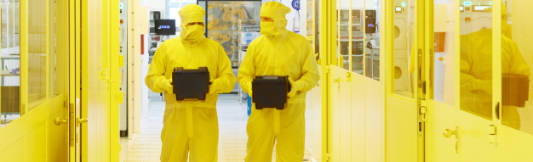

The “Golden Age Fabs” are the backbone of the semiconductor industry and deserve a lot of credit. But what can you do to take a mature fab to the next level and optimize yields, output, cycle times, operating costs and flexibility?

Join our webinar to learn more about the greatest potentials for semiconductor factories to effectively address the rising challenges and demands in manufacturing! Our guest speakers from 𝗕𝗢𝗦𝗖𝗛, 𝗡𝗲𝘅𝗽𝗲𝗿𝗶𝗮, 𝗖𝗼𝗵𝘂 and **SYSTEMA** will show you the automation path of very successful Golden Age Fabs.

[Please](https://www.fabmatics.com/events-2/forever-young-automation-makeover-rejuvenates-golden-age-fabs/) check out the full agenda on our website or simply click the link below to:

[](https://www.bigmarker.com/fabmatics-gmbh/Automating-Golden-Age-Fabs?utm_bmcr_source=Reminder)

Please register before February 24, 2021.

We are looking forward to welcoming you again soon!

Best Regards,

Kathrin Kammer, Fabmatics  
on behalf of the Automation Network Dresden